|  |  |
| --- | --- |
| Steps of Play  1. Dealer shuffles and deals each player 8 cards (remaining cards are the deck) 2. Player on the left plays first (states name, categories, and top value of category) 3. Next player plays higher in that category (states name, and value of category) 4. Continue till player can’t play. Player picks up a card from the deck and pass. Out of play until everyone passes (except one) or a supertrump 5. IF Supertrump is played; changes category (or win if Geophysicist + Magnetite) 6. Play until all pass and last player choose the trump category 7. Winner looses all their cards first, looser is last player with cards. | What the player sees  1. Main menu 2. Options for player count 3. Gets dealt card 4. Either plays first or sees first card played 5. Sees next cards played 6. Ability to add a card |
| Order of Coding  1. Make deck of cards/list of cards/array of cards from file with pictures 2. Show main menu with options (do other options later) 3. Choose number of players 4. Choose dealer [random int with dealer_ID variable being 0] and positions 5. Deal cards out (8 to each player) 6. Show player cards and deck 7. Left of dealer (number 1) goes first and plays card (shows name, category and top value) [If not player, need to rand card and rand category] 8. Next player ID plays or Passes 9. IF Pass, add one card to hand and out of play   Logic of play  Card 1 is played (must be mineral) and state category and top value  Card 2 is played, mineral card with higher trump value,  If card 2 isn’t played; must pass and pickup card  Cannot play until all pass OR supertrump is played. Pass is not mandatory | Inputs  1. .Case statement for input 2. Get user input on menu options 3. Number of players input from player 4. . 5. . 6. . 7. . 8. Possible input from player to play card   Create players  Deal cards  Assign player position with random collection (for player in players, player.setpostion = collection.get(i)  During play  Player.postion =  Play of card human  Show hand  Add numbers to each card in hand (1-8)  User input number 1-8  Index that number into the card array and remove from hand; also ad back into card deck/card table  If need to pickup, add a new card from the deck using the same code as dealing ecept only once.  Play of card bot  Same as human but random int number (card.size())  Use that number as index |

## Choosing dealer

## Dealing cards

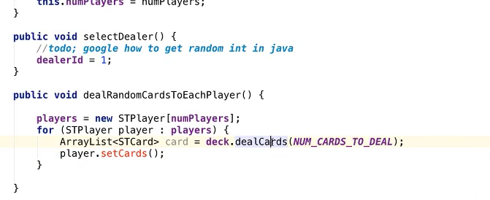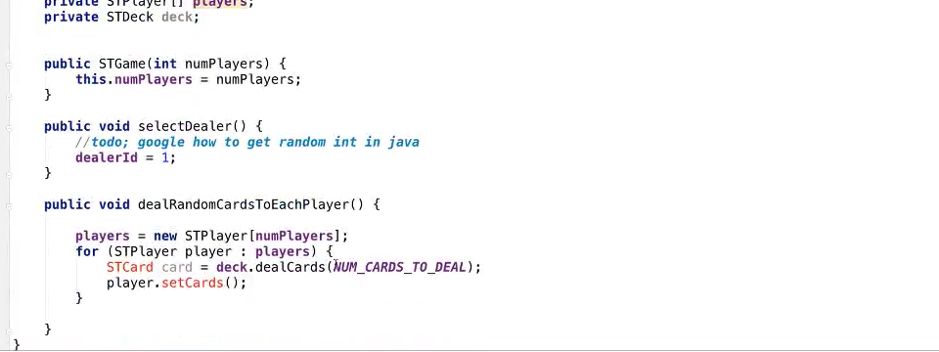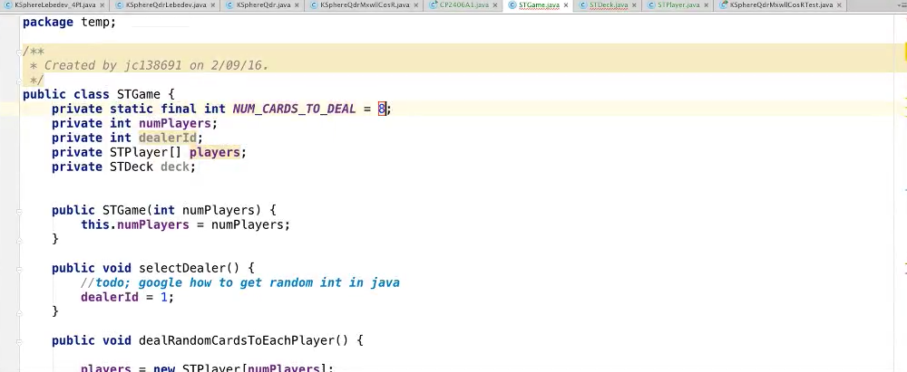

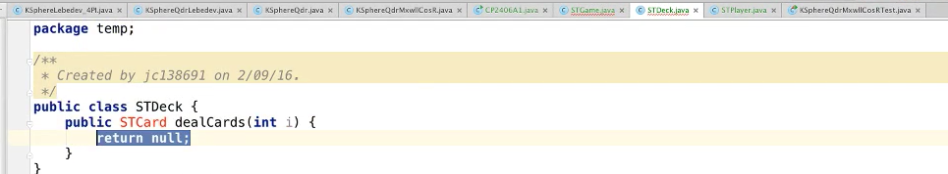

## List of Cards

